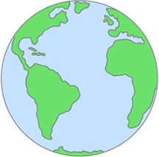


CIVIC SCORECARD
Being a civic leader is about all of the large and small actions we can take to be good neighbors and make our community a more positive place to live. Check off all of the civic actions you’ve completed:

Ate dinner with the person or people I lived with | Wrote an elected official about an issue I care  about | Visited my local courthouse | Did a favor for one of my neighbors | Attended a school, youth or club meeting
Voted in a school election | Read about my representative in the state legislature | Shared my thoughts in class or at a public meeting | Played a World Games sport with friends or classmates | Posted about a civic activity on social media
Visited a farmers market or local business | Encouraged someone younger than me to get involved | VISIT TWG2022.  COM | Attended a local arts or cultural event | Worked with others to solve a community problem
Attended a community meeting | Discussed a current event with a friend or family member | Researched a candidate running for office | Talked with an adult about how they  contribute to the community | Read about my representative in the state legislature
Read or watched  local or national news | Volunteered in my community | Visited a local or state park | Attended a local  pep rally or sporting event | Shared my perspective or idea with a local community leader

CIVIC SCORECARD CERTIFICATE

HOW DID YOU DO?!
Once you’ve completed the whole civic scorecard fill in the information below and mail your card back to: The David Mathews Center for Civic Life
P.O. Box 6
Montevallo, AL 35115

In return, we will mail you a certificate recognizing the important work you have done to make your community a better place!

Name:

Parent or Teacher Signature and Date: Date:

Mail my certificate to:

