REAL WORLD PROBLEM SOLVING

How might we create opportunities for students to explore real-world local and global problems and become empowered to make a difference?

The first step is to identify real-world problems. The United Nations Sustainable Development Goals are 17 goals that are an urgent call for action to resolve by 2030. The 17 goals are:



Visit the Sustainable Development Goals Knowledge Platform web page to explore each goal, progress made, and targets and indicators.

One strategy used by educators to support real world problem solving is by using Solve in Time cards. The cards guide collaborative student groups through the design thinking process to identify the problem, research, understand, solve and share within one class period (30 minutes) or or for an extended time to cover several class periods. Solve in Time uses cards to help students work through each step of the process.

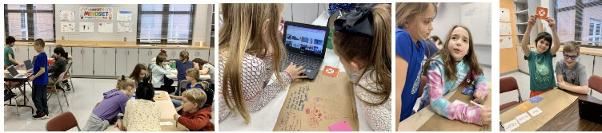
Below are instructions on how to use the free printable cards to work through real-world problem solving. You can also watch the Solve in Time intro video by Dee Lanier, creator of Solve in Time.

People

- There is one facilitator (instructor, teacher, group leader, etc.) that distributes cards and helps groups if they raise their SOS card (see more on that below).
- Participants split into teams of 2 to 4.
- Only one person per team can have a device. That person is the designated researcher and timekeeper.
- Another person per team is designated as the note-taker.
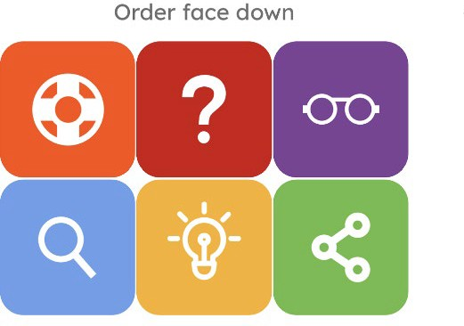

Problem

- The facilitator or teams can pick a problem to solve based on a theme, or topic, or whatever you like.
- It is best to choose a real problem that affects you or people that you care about.
- Each team can aim to solve the same problem or may select at least one different problem per team (ex: boredom, sickness, car-trouble, dog poop in your yard)!

Play

  - Each team is given one card of each color and places them face-down in order.
  - The first card is a help card called, SOS. This card serves as a reminder to players to collaborate and use all resources at their disposal before asking for help. If assistance is still needed from the facilitator, the group can raise their SOS card. Warning! If you use it, you lose it, so use it wisely! The following are recommended times for each of the five steps of Solve in Time!:
    - Problem 1-3 min
    - Research 3-5 min
    - Understand 3-5 min
    - Solve 3-5 min
    - Share 10-20 min

A facilitator presentation is available on the website to use in your classroom in Pear Deck or in Google Slides.

There are many different ways students can share their solutions. Explore the cross-platform creativity apps web page for ideas. Just a few creativity apps are: Adobe Spark, Book Creator, Buncee, Canva, Flipgrid, Glide, Google Tools, Kahoot, Loom, Made with Code, Novel Effect, Padlet, Scratch, Screencastify, Tinkercad, Tour Creator, and many more.

Got questions? Ask the creator or the community anything at flipgrid.com/solveit.

Also, visit the World’s Largest Lesson Plan web page for additional lesson plans and ideas supporting solving the sustainable goals.

